DevOps

Assignment 2017

Team Polo

Andrea Cole L00115856

Cathal Keany L00115066

Conor McGinty- L00117391

Liam Whorriskey- L00113360

Eimear Mc Cann- L00105764

Maria gibson- L00105748

B.Sc. in Computing

Enterprise Applications

Assignment 2017

Health insurance On-line system to enter

Customer’s details

By

Team Polo

Andrea Cole L00115856

Cathal Keany L00115066

Conor McGinty- L00117391

Liam Whorriskey- L00113360

Eimear Mc Cann- L00105764

Maria gibson- L00105748

Requested By

Lecture: Ruth Lennon

**Introduction**

**Project Overview**

This project has been developed by Group2 Team Polo for an Assignment in DevOps at Letterkenny Institute of Technology.

The system has been developed for a health insurance company, enabling customers to use an online system to enter their details. This system is designed to calculate the risk and produce the cost of insurance for the client. This is a secure system that’s takes in personal details, private health information and foreign travel.

Development has progressed over a number of weeks. This included individual work at home and group sessions in study rooms on a weekly basis. Meetings were scrum style Stand-up meetings to review progress. Working as a team the specification was defined. As the project progressed, Jira was used to track ongoing tasks. GitHub repository was created to push documentation and upload code.

This document will provide an overview of the system planning, development and team integration.

**Scrums**

In the first Scrum Meeting Use Case and State diagrams for health Insurance project were drawn.

All team members were present and contributed input to design outline and requirements.

Results are as follows:

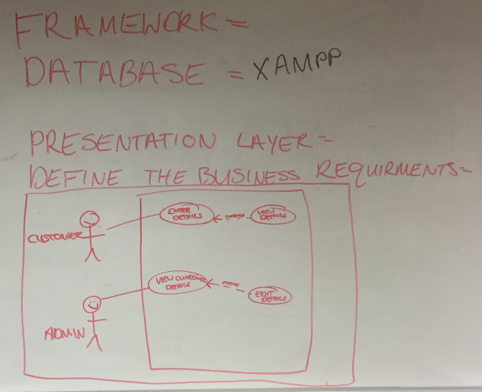

**Fig 1 Use Case Diagram Customer**

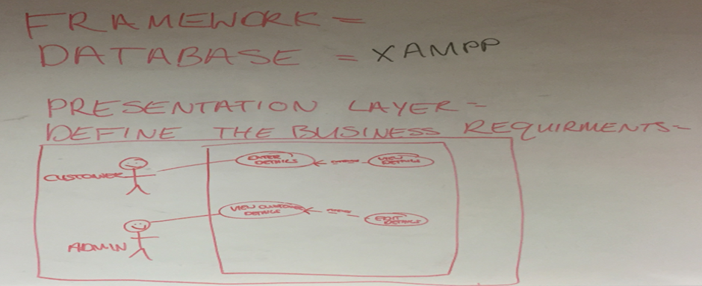 **Fig 2. Use Case Diagram Administrator**

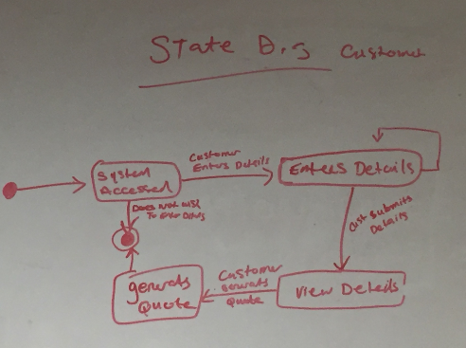

**Fig 3. State Diagram Customer**

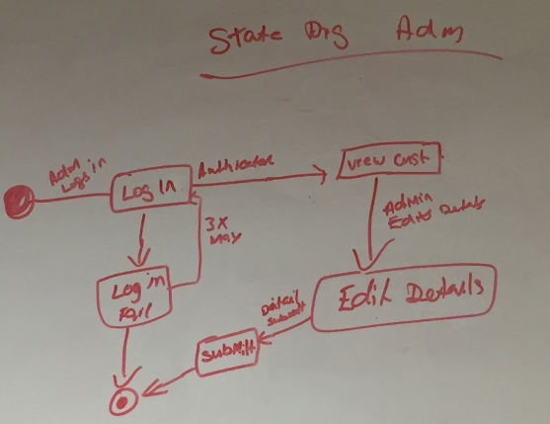 **Fig 4. State Diagram Administrator**

**Summary**

Research was conducted into application design, testing, database development and web application. Results will highlight reason for chosen path in conducting this project. Java connection has now been requested for by Customer.

**Technical description of the project**

The web application will be hosted on a cloud server link192. The web application consists of a MySQL database that was created on AWS as a RDS instance this was moved to PHP MyAdmin.

The database is connected using PHP to the website. The database contains two tables customer and customer quote. The parameters in the database define the loadings to calculate the customers health insurance quote.

* ERD/Class Diagram- (To Do)
* Tables- Please see appendix

**Methodology (SDLC)**

The team decided to implement an Agile approach to project. This was chosen to allow team members to work to their strengths and independently. In an Agile team, all members must contribute equally during sprints and no team lead is assigned. When defining requirements for system various team members nominated themselves for preferred primary piece of work. The project was broken up into the front-end requirements, middle ware requirements and backend.

**Application Design**

**Database Design**

Reasons for using an SQL database for application

1. **High Speed**.

SQL queries can be used to search and fetch high volumes of data from database in a quick and efficient manner.

1. **Easy to Manage**

Using standard SQL means it is easy to manage the database without the need for a lot of code.

1. **Supports OOP**

SQL can support and communicate with object orientated programming e.g. java and JavaScript which makes it flexible when using a database for applications.

1. **Compatibility**

SQL Database can be used with Bootstrap which is the open source front end framework selected for the online application.

An RDS database has been created on AWS by Eimear on her aws account.

Hosting it on the cloud made it easier for two team members (Andrea and Eimear) to work on the database.

Access connection to the database on SQL workbench paste the following - *devops.cyivwen45nzy.us-east-2.rds.amazonaws.com*

Into the host section when setting up a new connection.

Use port 3306.

The password is grouppolo

Security group has been configured so anyone can access the database which is convenient for the purpose of this project

Polo Insurance Instructions

Created an SQL database for Polo Insurance on an Amazon AWS server so it can be accessed by everyone. Two sample tables were created like discussed, Customer_table, which will include Name, address, phone etc, and a Quoate table, which will include if the customer is a smoker or travels outside Europe or US and so on. These tables will be updated as we move forward as a team. Please use the following Hostname on My SQL Workbench when connecting to the database. The Log in details are noted below to allow access to the database. Any issues with this database can be updated easily so don’t hesitate to contact me through our group email or in the next sprint. Some sample data was also entered to test the database.

**UserName:** Devops

**Password:** grouppolo

1. Download MySQL work bench (.NET and Visual c++ 2015 will have to be downloaded as prerequisites).
2. + to add a new hostname and enter the hostname stated below.
3. UserName and Password will have to be entered that is stated above.

**HostName:** devops.cyivwen45nzy.us-east-2.rds.amazonaws.com

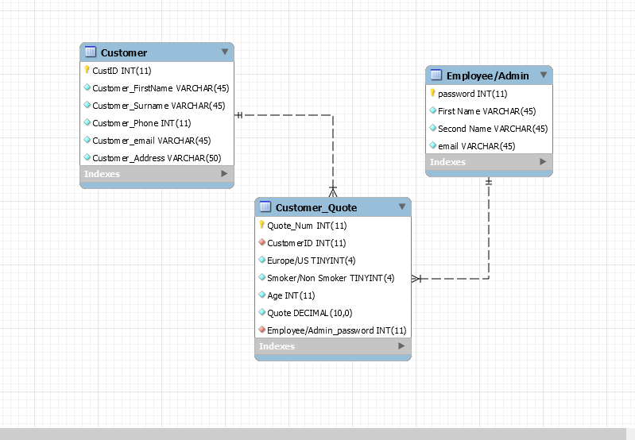

Fig 5. ERD Diagram- Revers engineered in database

**Web Development:** Liam Worskie, Maria Gibson. As Maria had no prior experience on Web Development Liam agreed to mentor Maria in web design through a series of meetings to discuss design and development.

Discussion on Layout of web design page:

|  |
| --- |
| Navigation  Header  Side Bar  Content  Quote  Footer |

**Fig 5. Web Page Design**

Prototype – Web Page Access on link192.com /http://link192.com/agents.php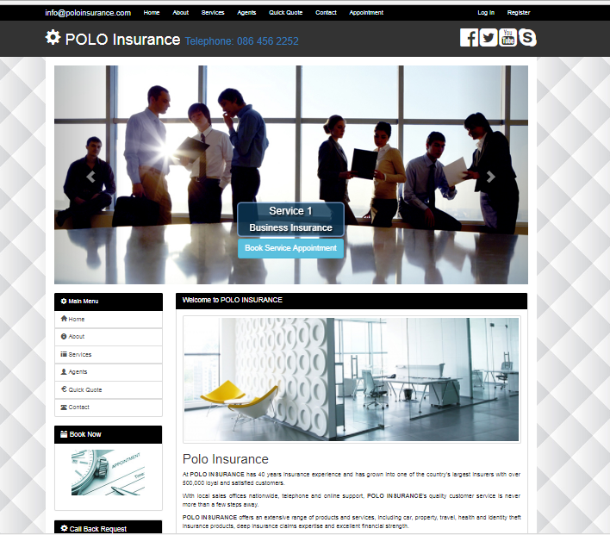

Fig 6 Home Web Page

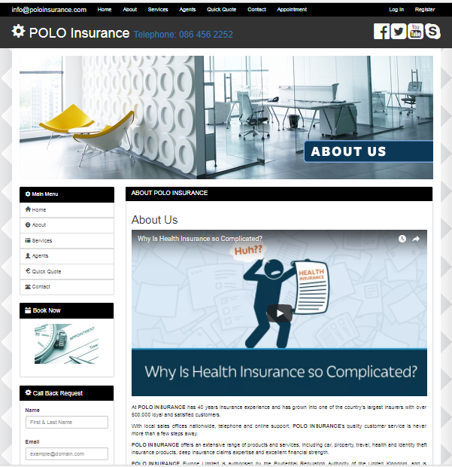

Fig 7. About Webpage

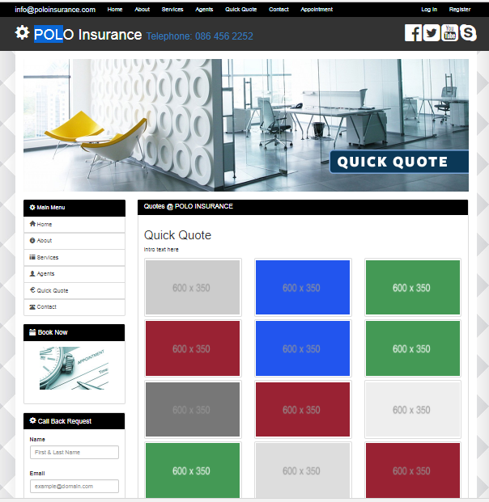

Fig 8. Quick Quote Webpage

New Proposed Contracted

Customer Meet with Polo Insurance to review new requirements. The following agreement was reached and is highlight below in fig 9.New Contract Proposal

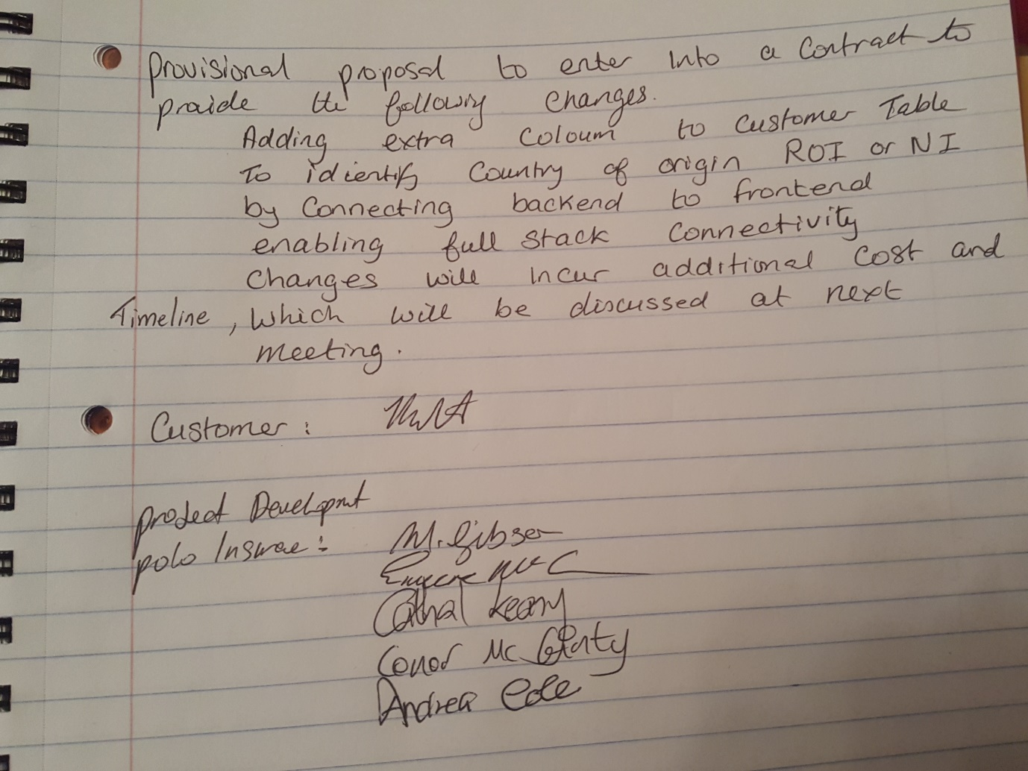

**Appendices**

**Sample Tables in Database**

**Table 1.1**

**Customer Table**

|  |  |  |  |  |  |
| --- | --- | --- | --- | --- | --- |
| **ID** | **Name** | **Surname** | **Address** | **Email** | **Phone No.** |
| **Primary key** |  |  |  |  |  |
|  |  |  |  |  |  |

**Table 1.2**

**Quote Table**

|  |  |  |  |
| --- | --- | --- | --- |
| **Europe/US** | **Smoker/NonSmoker** | **Age** | **65+?** |
|  |  |  |  |